

Daftar Publikasi Advetorial Reels Instagram Diskominfo Batola Bulan Oktober 2025
https://www.instagram.com/suluhbanua/reel/DQEZLjLkUbL/ | 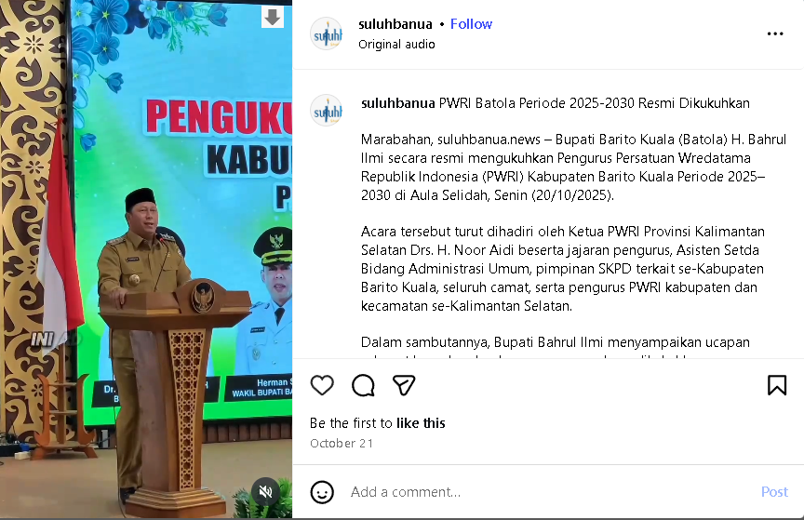
https://www.instagram.com/suluhbanua/reel/DQG9rFBkVwX/ | 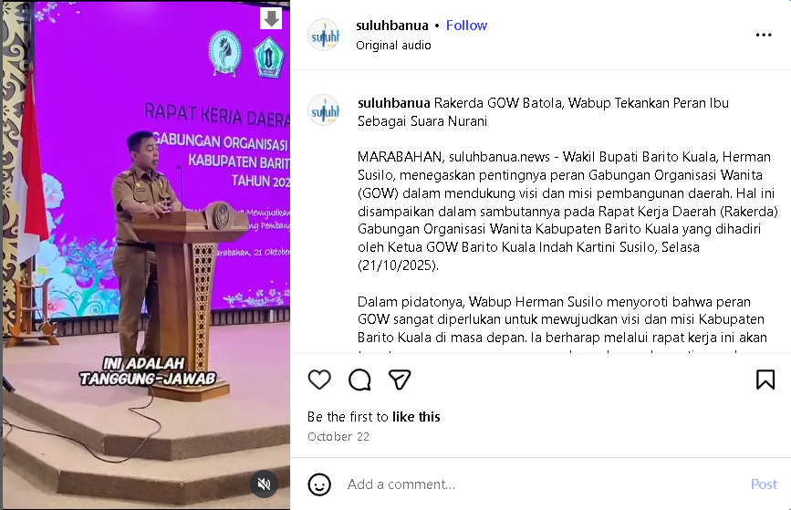
https://www.instagram.com/suluhbanua/reel/DQG-EMmEeta/ | 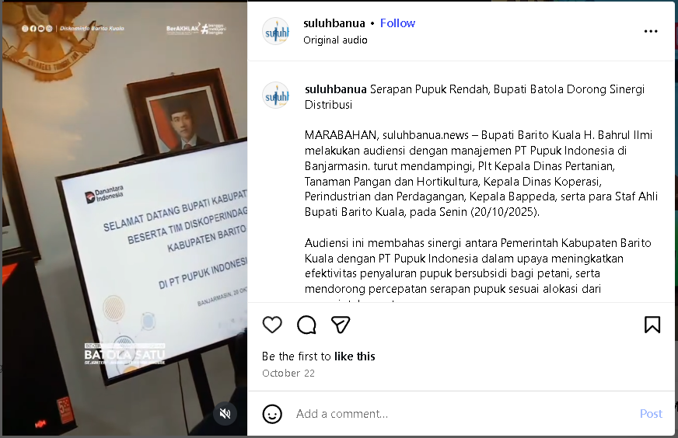
https://www.instagram.com/suluhbanua/reel/DQG_JC9kc3K/ | 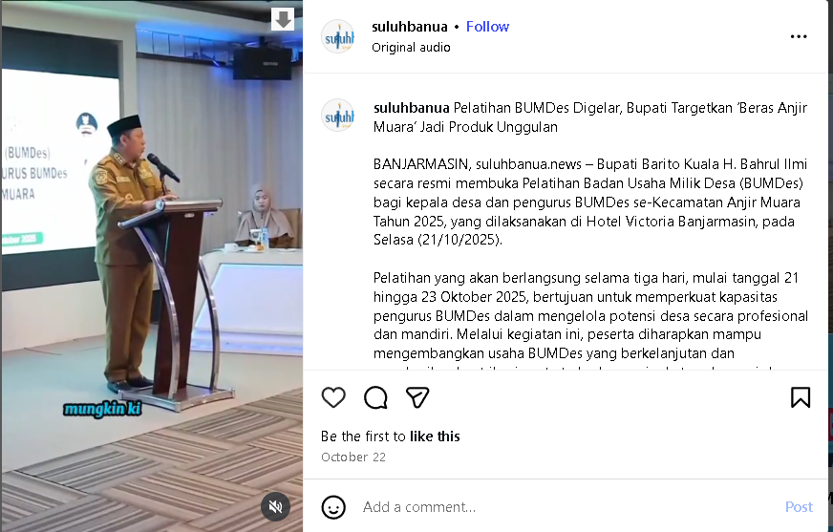
https://www.instagram.com/suluhbanua/reel/DQI2o6WEacW/ | 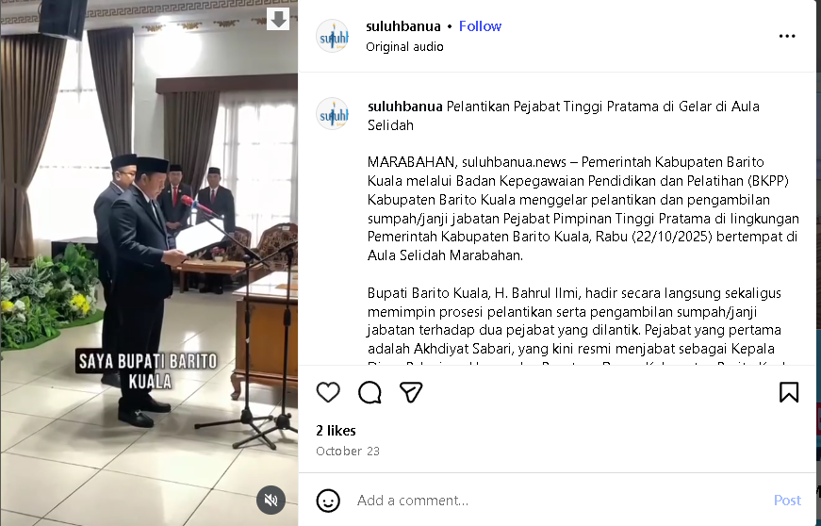
https://www.instagram.com/suluhbanua/reel/DQKJ2fDj0Ii/ | 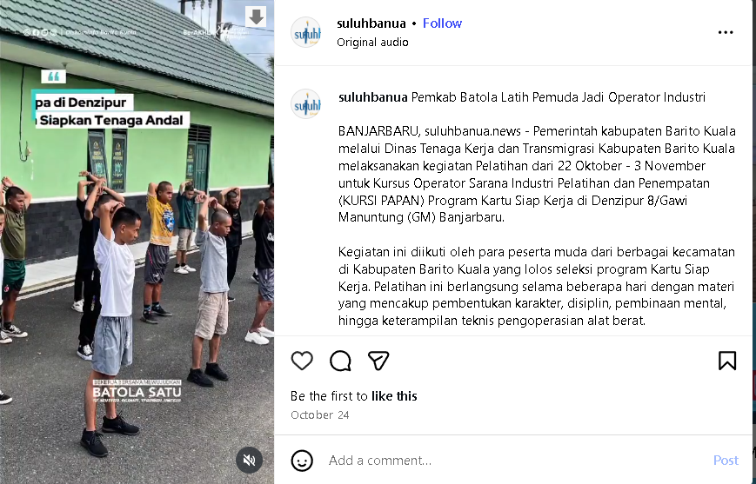
https://www.instagram.com/suluhbanua/reel/DQKJ9zJjzj7/ | 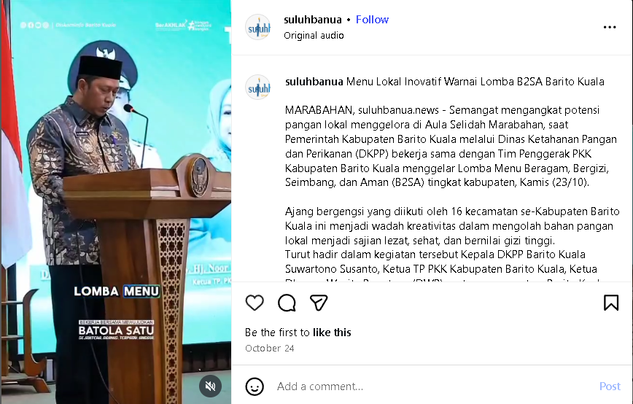
https://www.instagram.com/suluhbanua/reel/DQOqm5lEcUj/ | 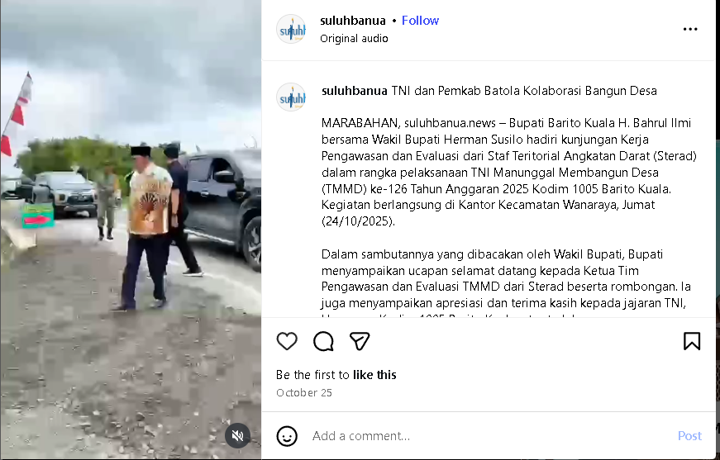
https://www.instagram.com/suluhbanua/reel/DQO03ywD6Q6/ | 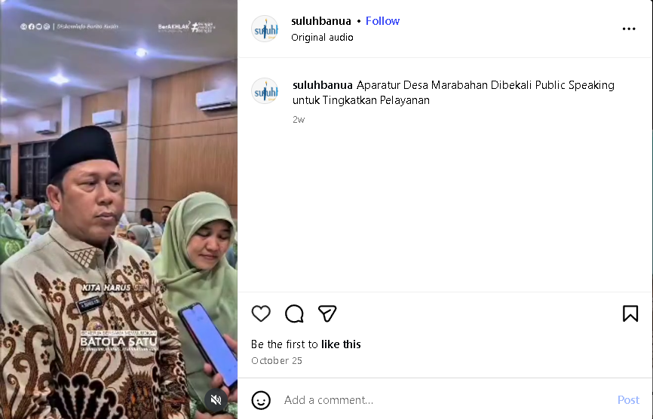
https://www.instagram.com/suluhbanua/reel/DQWFWdYEWdi/ | 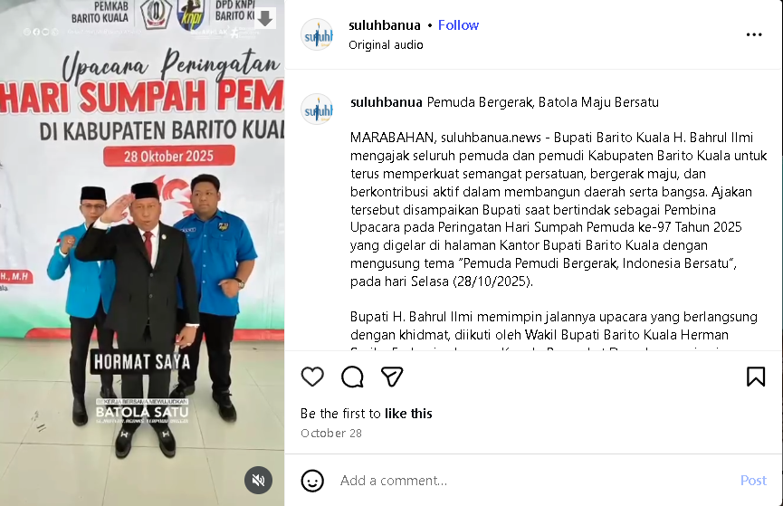
https://www.instagram.com/suluhbanua/reel/DQY5yYtkWJh/ | 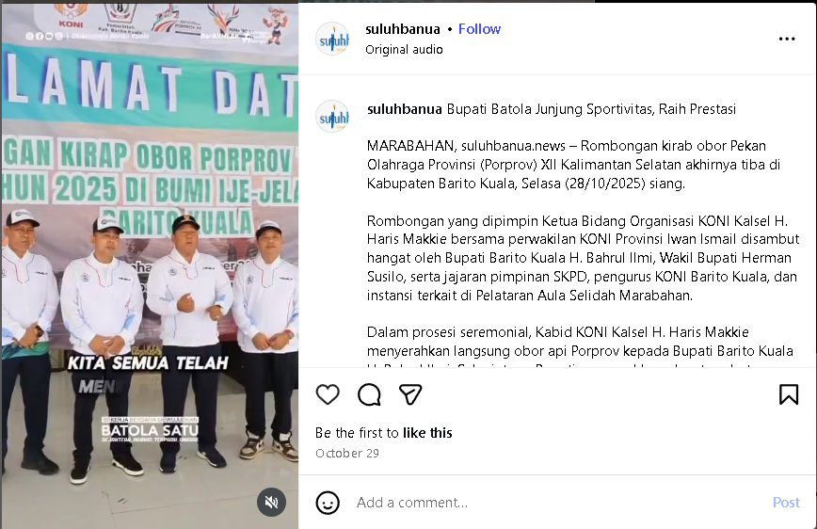
https://www.instagram.com/suluhbanua/reel/DQb6ytBjzhf/ | 